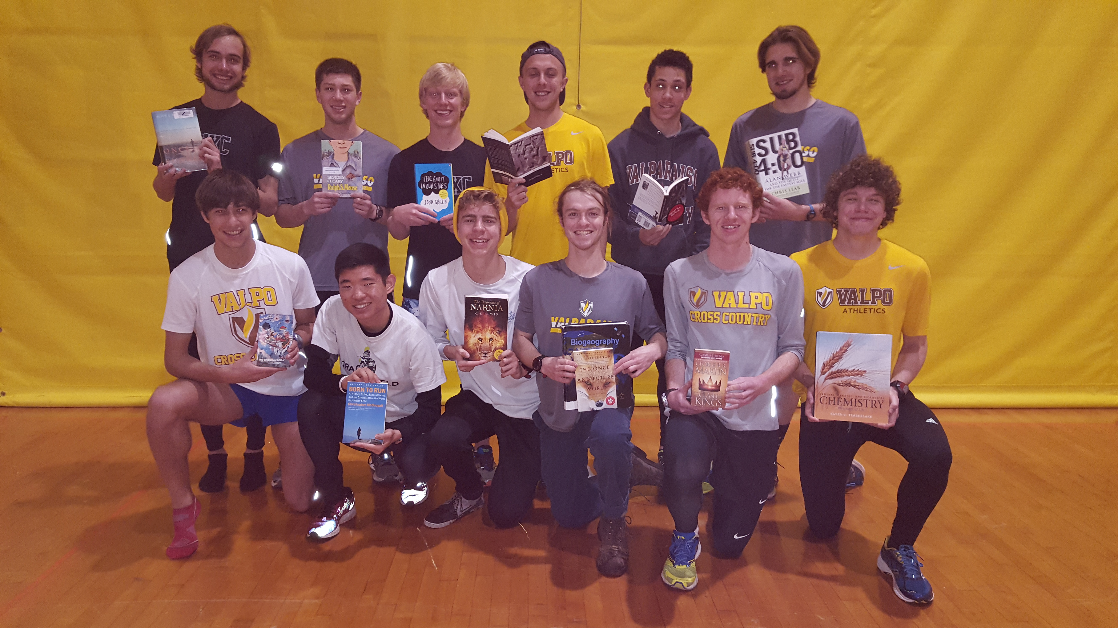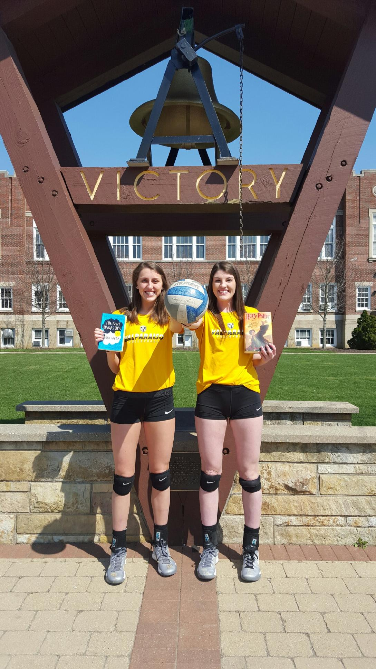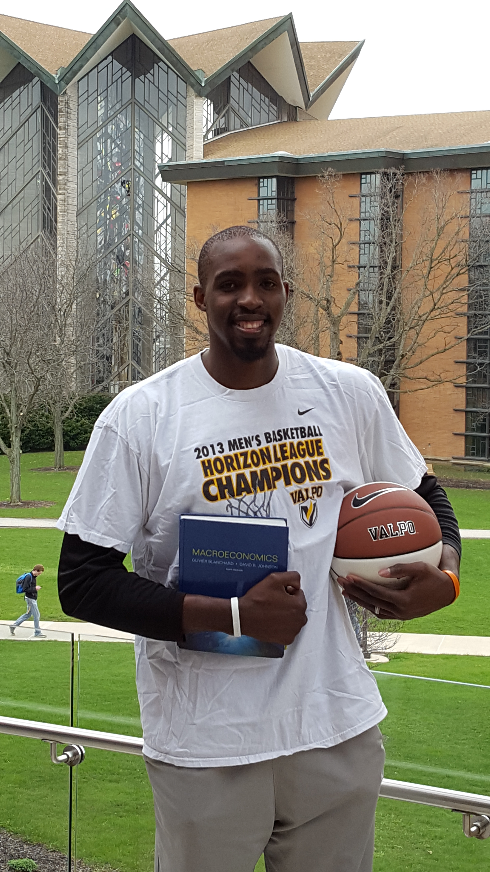

**REGISTRATION REQUIRED**

**valpo.edu/education***You will receive an email confirmation*

\***Registration deadline**

**October 28, 2019**

College of Arts and Sciences, Department of Education • 219-464-5077 • Email: valpoteach@valpo.edu

This event is being sponsored by the Professional Educators Partnership (PEP);

Mathematics and Science Education Enrollment Development (MSEED)

Discover the Art of Teaching at Valpo

**What to Expect on November 6, 2019**

At **Discover the Art of Teaching**, you will:

• Explore exciting opportunities for future teacher leaders

• Learn about campus life – College 101 student led panel discussion

• Experience campus via a student-led tour

• Attend a motivational talk and mock class demonstration

• Enjoy lunch with current education students and faculty

**\*Need more information on our Education Programs,**

**please visit www.valpo.edu/education.**

*“A good teacher can inspire hope, ignite the*

*imagination, and instill the love of learning.”*

*-Brad Henry*

This event is an opportunity for high school juniors and seniors who are interested in pursuing the teaching profession as a career. ***Discover the Art of Teaching*** provides an opportunity to explore a teacher's career path with current education students and faculty.

The mission of the Education Department at Valparaiso University is to recruit, prepare and support young people in our profession who will become part of the next generation of high-quality and inspirational teachers.

The event will be held at Valparaiso University, Christopher Center Community Room, on **Wednesday, November 6, 2019.** Students interested in attending may register on-line at <https://www.valpo.edu/education/discover-the-art-of-teaching-2/>**.**

**Tentative Schedule**

**8:30 - 9:00 a.m.**

Check-In & Breakfast in

Christopher Center, Community Room

**9:00 – 10:20 a.m.**

Welcome Future Teachers & Guests

The Vocation of Teaching

STEM Activity

**10:30 – 11:00 a.m.**   
Conversation with Valpo students, Center for the Arts, Dusenberg Hall

**11:00 a.m. - 12:40 p.m.**

Campus tours lead by current students Lunch, Harre Union, Hearth Room

**12:45- 1:00 p.m.**

The College Application Process, Christopher Center, Community Room

**1:00 p.m.**

Closing remarks

*Optional Afternoon Activities:*

**1:15- 2:00 p.m.**

Admissions Questions

**1:15- 2:00 p.m.**

Campus Ministry and Chapel Life