Plastic waste is a current and ongoing threat to the environment and human health around the globe. Plastic-based pollution, which does not decompose, makes up a large portion of garbage generated locally and globally. In the US and in Porter County, the recycling rate for plastics that are recyclable is less than 10%. Projections indicate significant growth in plastic production over the next decades, while research is exposing the threat of plastic pollution to all ecosystems and the health dangers associated with the micro- and nanoplastics created from everyday plastics.
The Porter County Waste Reduction Initiative or the PCWRI is a partnership between Valparaiso University and Porter County Recycling and Waste Reduction District. The program was implemented to help the community understand how much single-use plastic that they are using on a day-to-day basis. This program is designed to help the community take accountability for the amount of plastic that they are using and reduce the amount of single-use and non-recyclable plastics going into the various landfills within Porter County. The Porter County Plastic Audit Program focuses on education, data, research, and behavior changes. Be a part of the solution, not the problem!
The PCWRI is wanting to collect valuable data on how much plastic waste is being generated and used in our community. By doing an at-home plastic audit, and sending the data back to Valparaiso University, we will have a better understanding of what materials our Porter County Residents are using and what areas we should be focused on to help better recycling practices and reduce plastic consumption. If you are a resident of Porter County please fill out the survey below with your audit data.
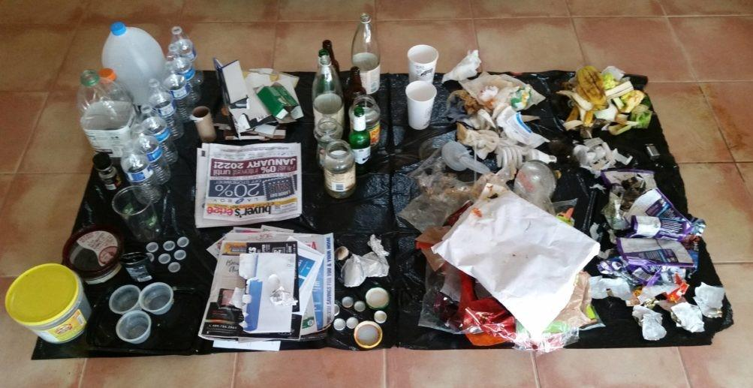

Needed Materials
Tarps to sort waste onto (Trash and recycling bags cut open and laid out flat could also work for this)
Disposable gloves

Plastic Audit Instructions
Steps:
- Collect your trash and recycling and record for how many days you have been collecting
  - You can also choose sort it throughout the week instead of doing it all at once so that you can keep some recycling less contaminated than if it were all together in the trash.
- Sort the items into the categories.
- Starting counting how many items are in each category and write the totals down on your spreadsheet.
- Dispose of each waste category properly
- Continue this process every time you take out the trash for a week.
- At the end of the week, put your totals into our online form and submit it to us. forms.gle/JFhfwHFdfZCjtnCe7

Waste Category Chart:
Waste type | Examples
Cardboard (Recyclable) | Shipping boxes, cereal boxes, soda cases, paper cups (lids removed and no liquids), orange juice/milk cartons, juice boxes (remove straws), paper egg cartons NOTE: Greasy pizza boxes CANNOT be recycled
Paper (Recyclable) | Newspaper, magazines, junk mail, office/school papers, envelops, books, paper bags, etc.
Metal (Recyclable) | Aluminum and steel cans, pie trays/party size disposal pans, small scrap metal
Glass (Recyclable) | Glass bottles, jars, and food containers. (Window glass, drinking glasses, candles, etc. are not recyclable)
Bottle/Jugs/Recyclable Cups (Recyclable) | Household plastic bottles and jugs from things like soda, water, detergent, milk, soap, etc. (Soap pumps and sprayers from cleaning bottles should be removed as these contain a metal spring. Normal caps and labels should remain on). Plastic cups with a #5 are also included.
Flexible plastic packaging (Not Recyclable) | Chip bags, candy wrappers, squeezable apple sauce and baby food pouches, other flexible food packaging
Mixed Plastic | Items such as pens, expo markers, toothbrushes, mascara, luffa, dish brush, etc. can be considered mixed plastic because even though Plastic is their main component, there are other
Take Out Boxes/ Packaging (Not Recyclable) | All hard plastic takeout containers from restaurants.
Plastic Lids/ #6 PS Cups | Commonly found on paper soft drink and coffee cups. Red solo cups are also #6 plastic. Look for anything with a #6 in the triangle.
Utensils/Straws | All plastic cutlery and straws. This material is too small to be sorted at the recycling facility and falls through the glass sorting screen.
Styrofoam | Cups, Togo boxes, packaging from products, and more can all be made of Styrofoam.
Electronics/Batteries | TVs, computers, phones, cables, lamps, clocks, calculators, kitchen appliances. Anything with a plug.
Trash | Napkins/paper towels, paper that had been contaminated by food or liquid, paper or cardboard takeout containers and fast food packaging, shredded paper.

